Country Quiz:

Using HTML, CSS, Django and Python

Requirements:-

Python 3.10

Django 4.1

Working:-

1.Run the command python manage.py runserver command which is used to run the server. Then the display will visible like this

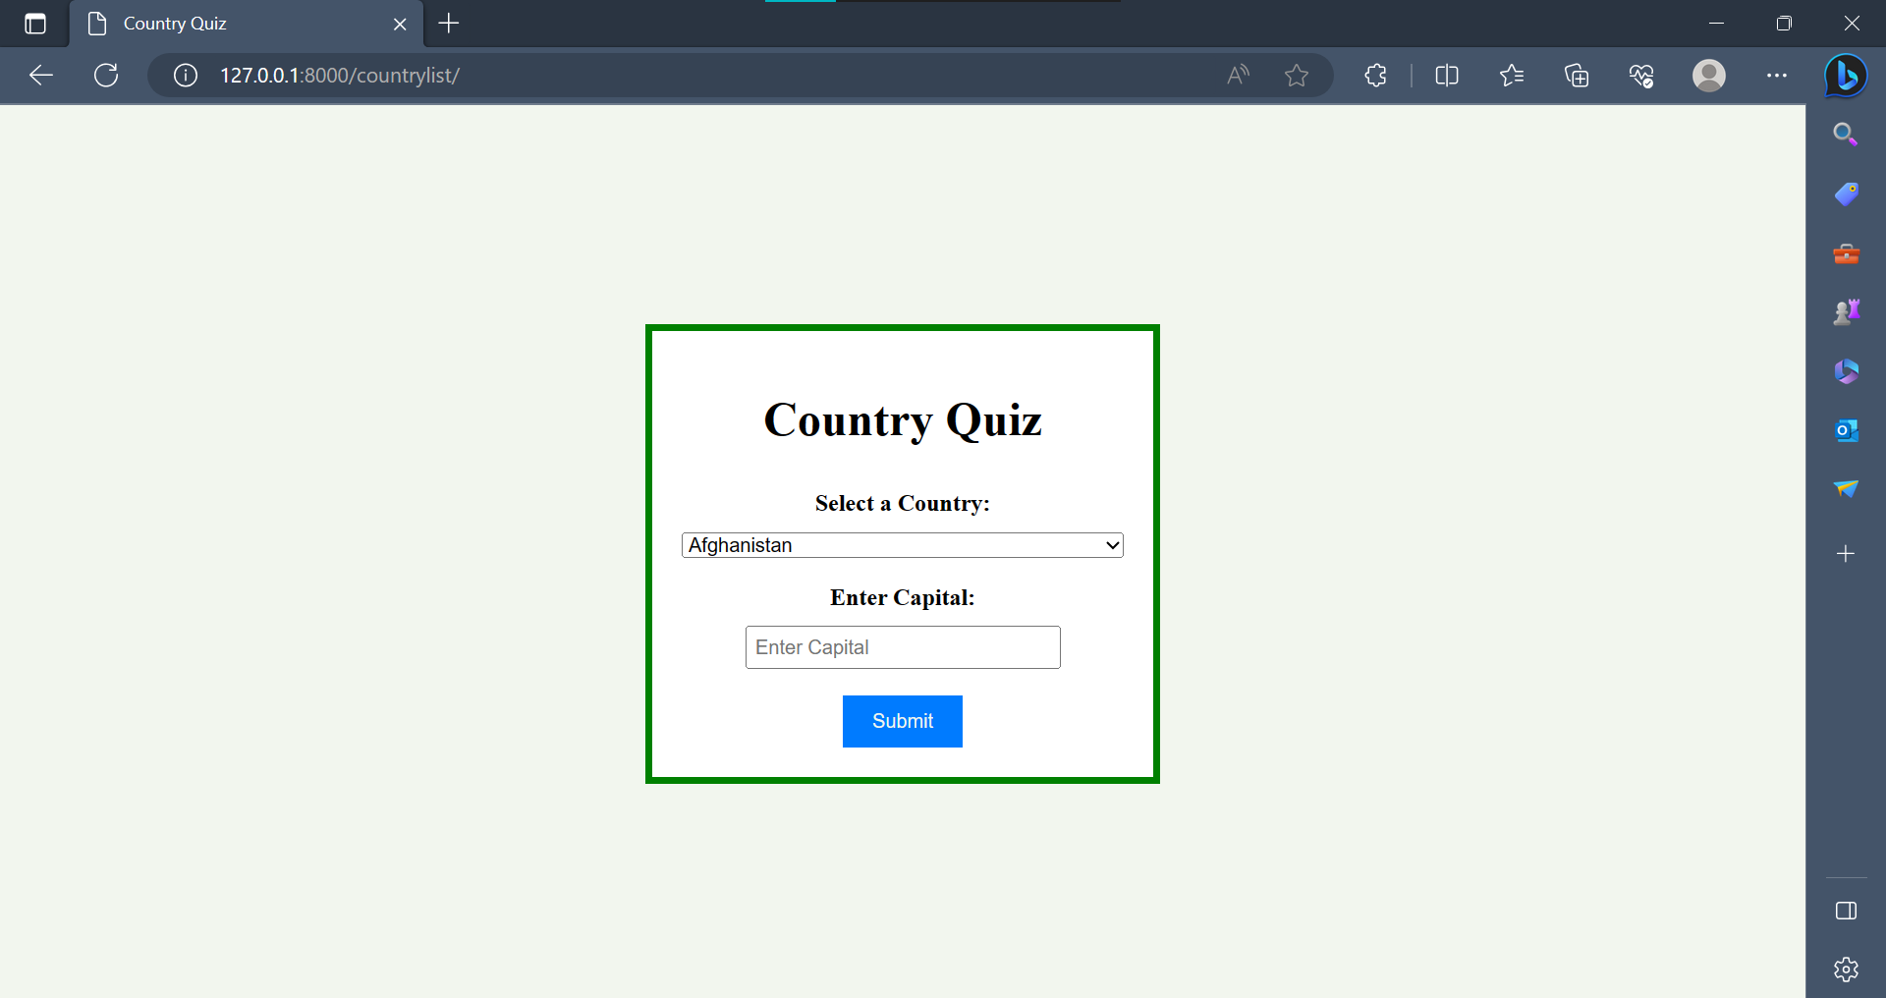

2. Here we select the country which we want and enter the capital manually.

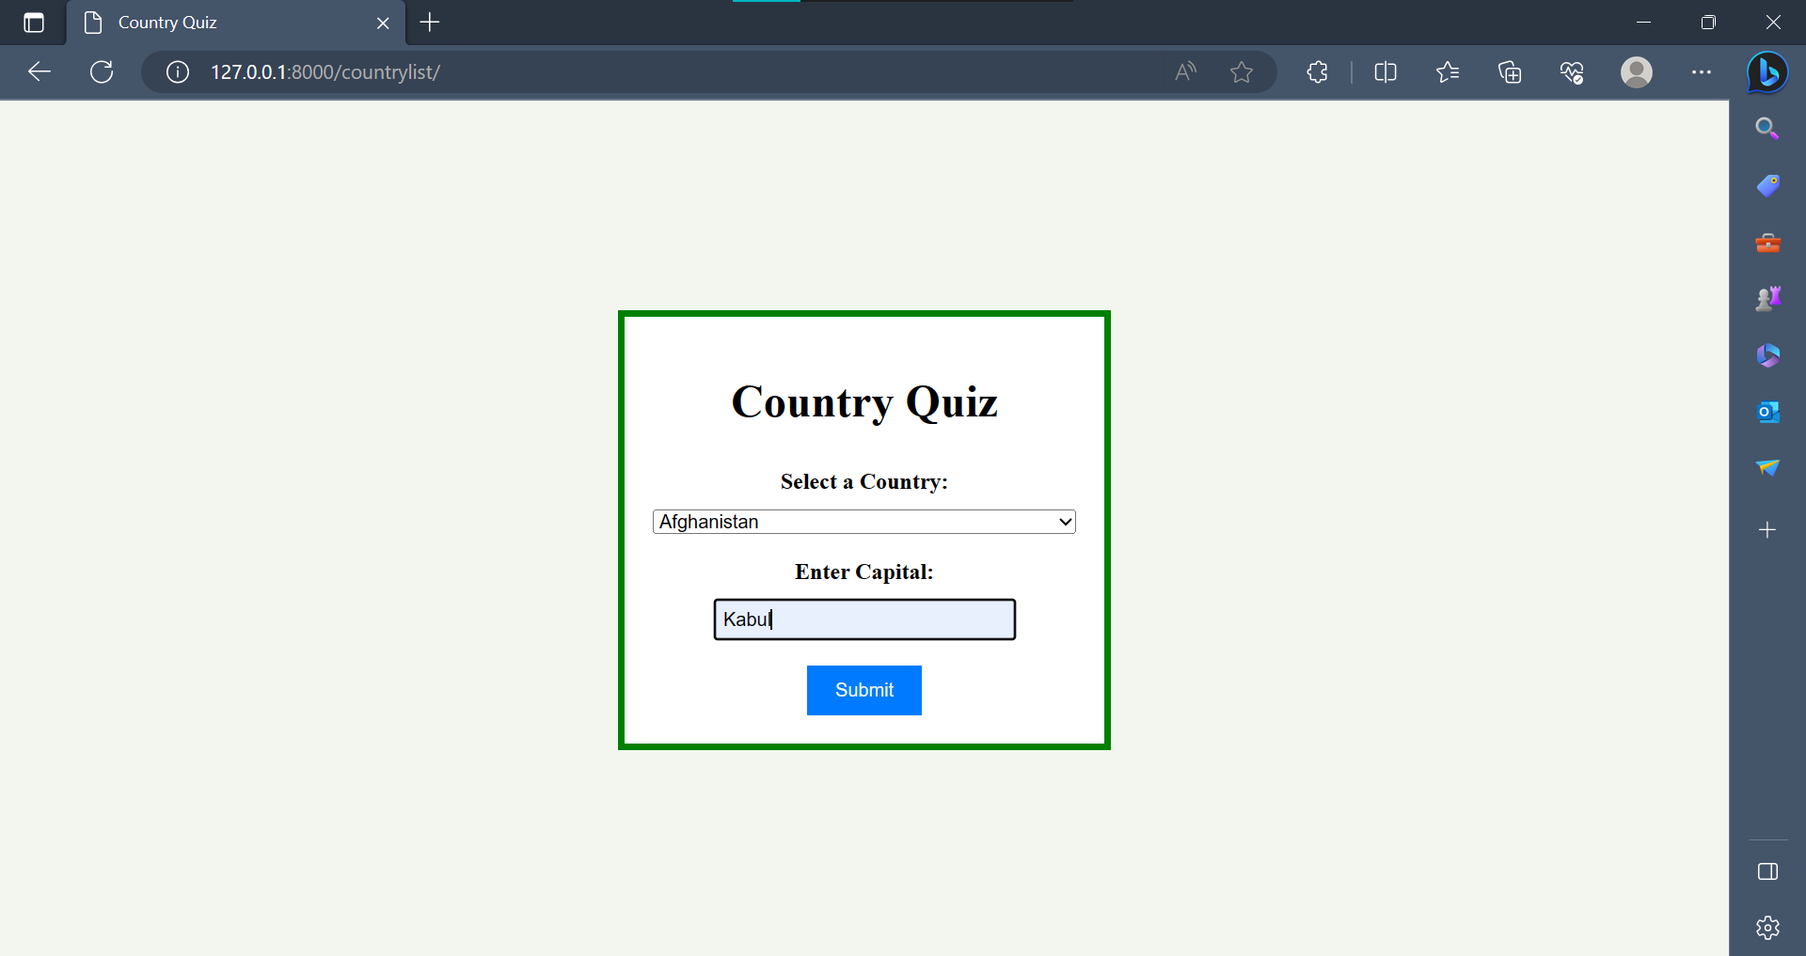

If the answer is true then it will display like this

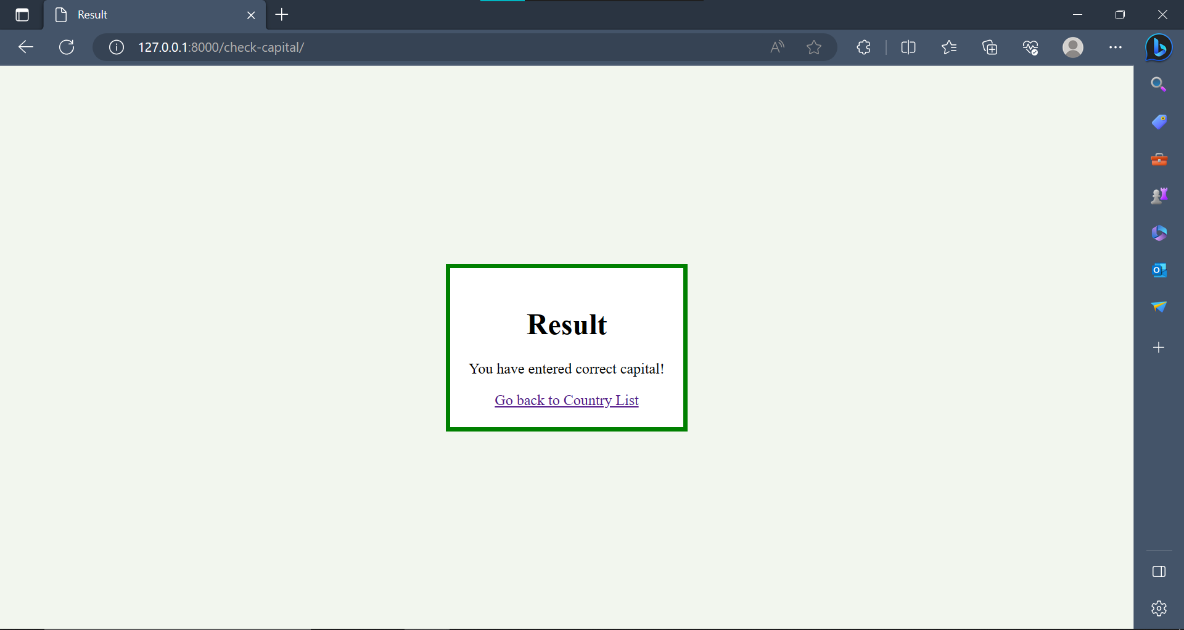

3. If we enter incorrect capital like this

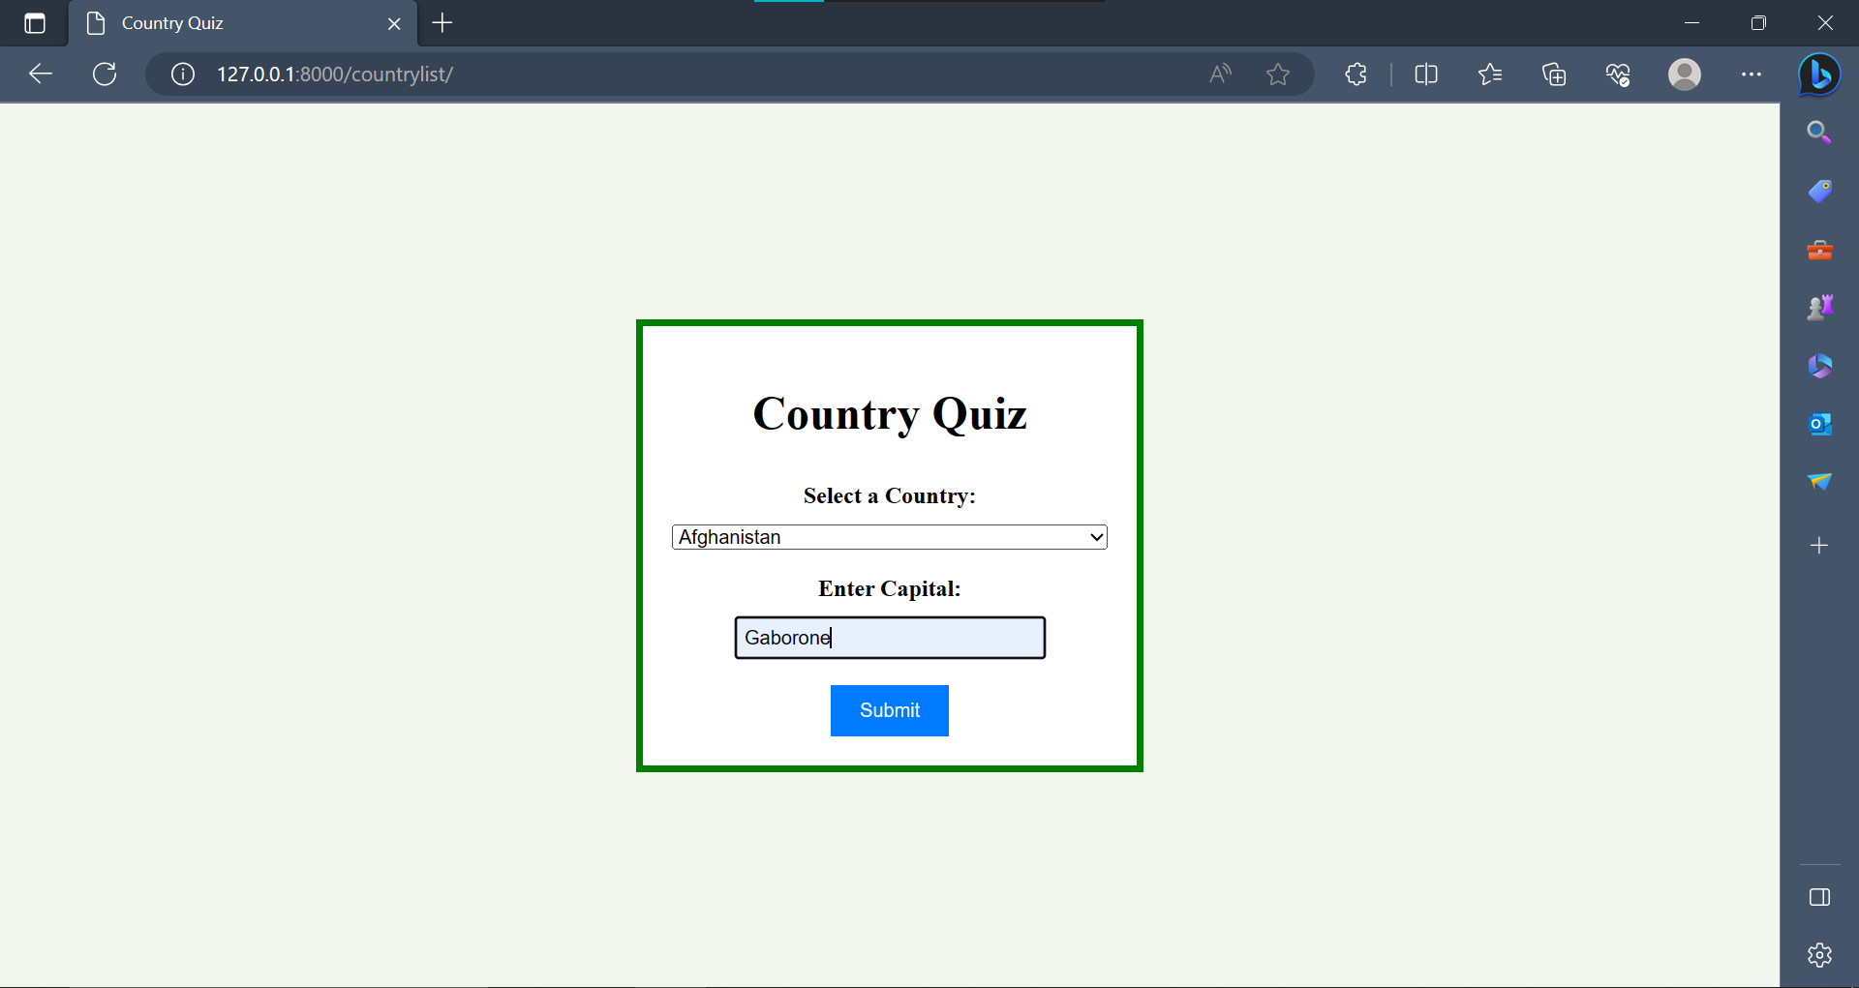

Then it will display with the correct answer.

